**CREATE A PL/SQL PROGRAM USING CONTROL STATEMENT TO GENERATE A PROGRESS REPORT FOR A STUDENT. SPECIFY THE GRADE ABOVE 90 OUTSTANDING, ABOVE 80 DISTINCTION, ABOVE 70 GOOD, ABOVE 60 FIRST-CLASS, ABOVE 50 SECOND-CLASS AND BELOW 50 FAIL.**

**i)WITHOUT TABLE**

CREATE OR REPLACE PROCEDURE sd(

name VARCHAR2,

id NUMBER,

m1 NUMBER,

m2 NUMBER,

m3 NUMBER,

m4 NUMBER

)IS

a NUMBER;

BEGIN

a:=(m1+m2+m3+m4)/4;

dbms_output.put_line('Student Name: '||name);

dbms_output.put_line('Student ID: '||id);

IF a>=90 THEN

dbms_output.put_line('OUTSTANDING');

ELSIF a>=80 AND a<90 THEN

dbms_output.put_line('DISTINCTION');

ELSIF a>=70 AND a<80 THEN

dbms_output.put_line('GOOD');

ELSIF a>=60 AND a<70 THEN

dbms_output.put_line('FIRST CLASS');

ELSIF a>=50 AND a<60 THEN

dbms_output.put_line('SECOND CLASS');

ELSE

dbms_output.put_line('FAIL');

END IF;

END;

/

BEGIN

sd('Virat',1818,95,89,93,88);

END;

/

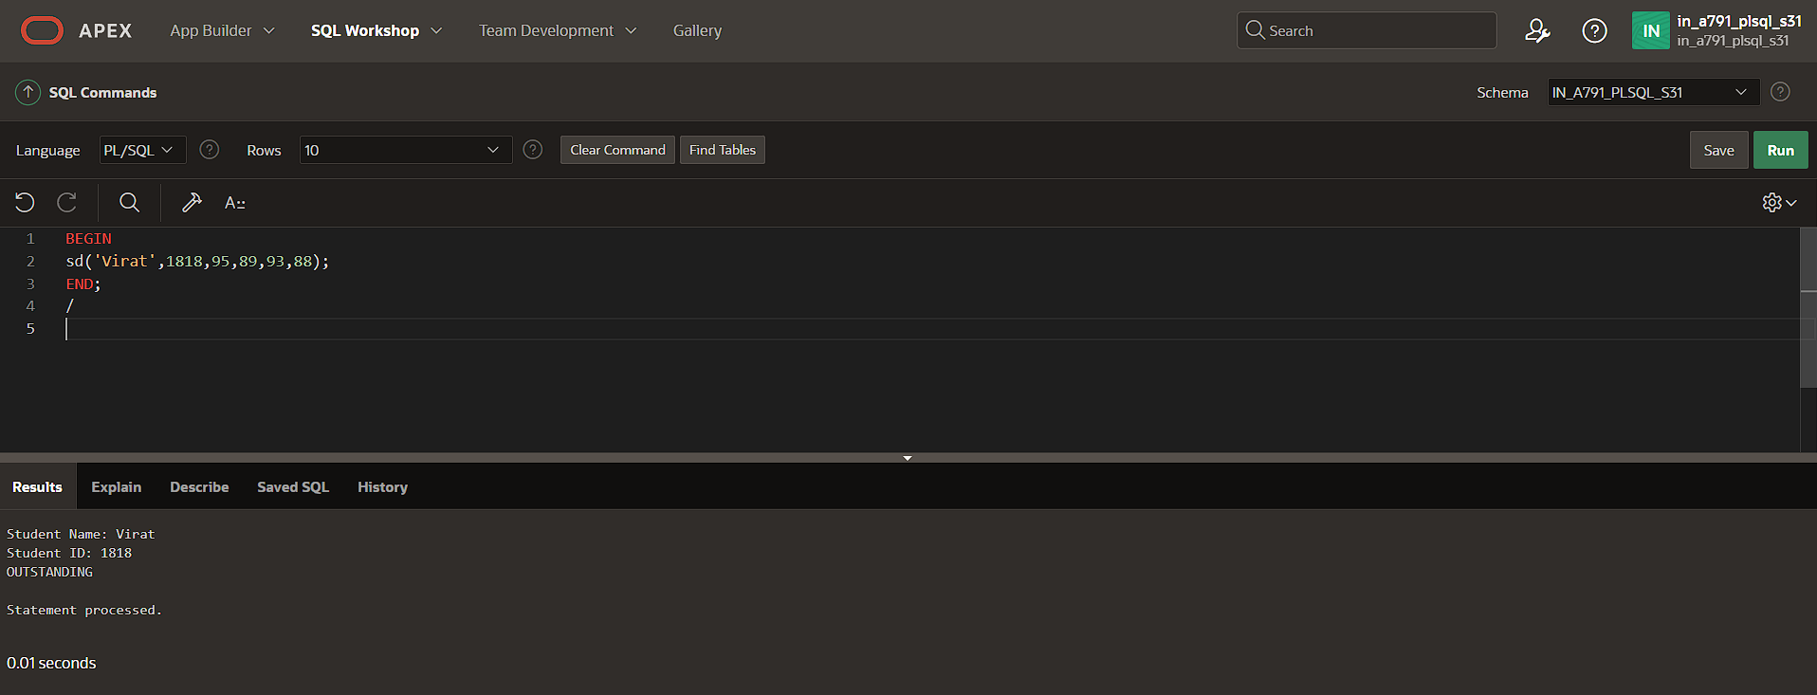

**ii)WITH TABLE**

CREATE TABLE stumark(student_id NUMBER PRIMARY KEY,name VARCHAR2(100),m1 NUMBER,m2 NUMBER,m3 NUMBER,m4 NUMBER);

INSERT INTO stumark VALUES(1818,'Virat',95,89,93,88);

SELECT*FROM stumark;

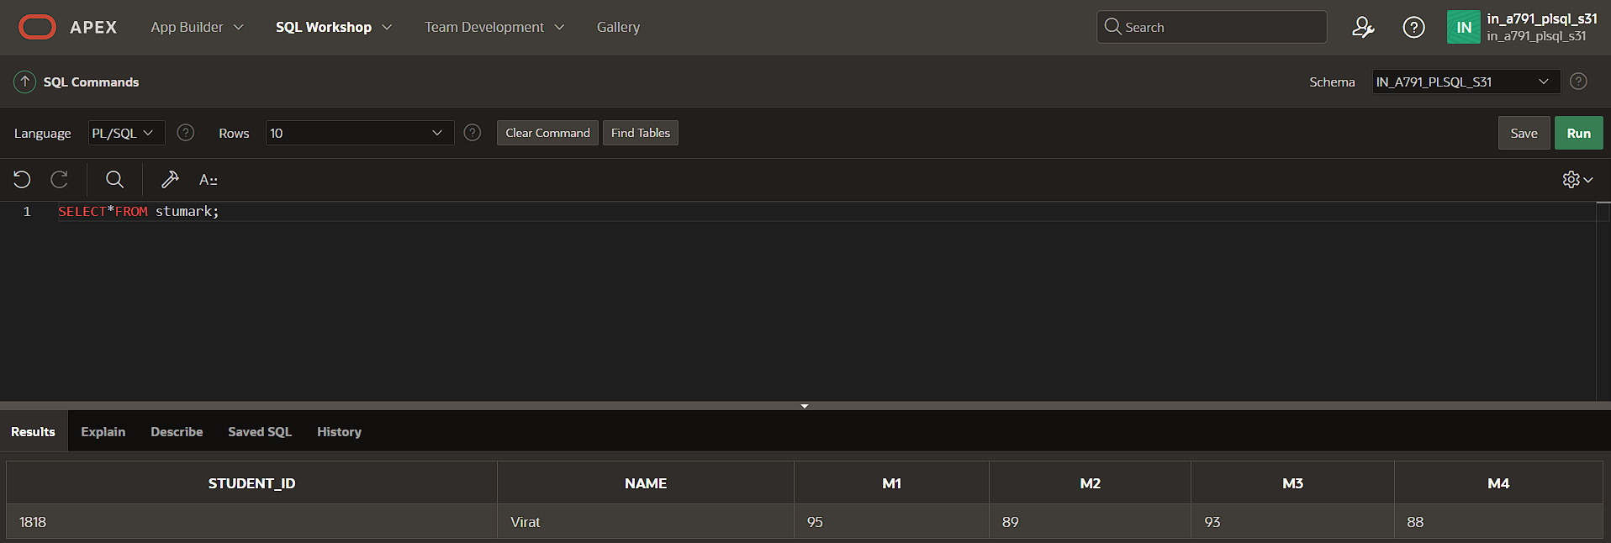

CREATE OR REPLACE PROCEDURE sd(

a NUMBER

)IS

vname VARCHAR2(100);

vm1 NUMBER;

vm2 NUMBER;

vm3 NUMBER;

vm4 NUMBER;

vavg NUMBER;

BEGIN

SELECT name,m1,m2,m3,m4

INTO vname,vm1,vm2,vm3,vm4

FROM stumark

WHERE student_id=a;

vavg:=(vm1+vm2+vm3+vm4)/4;

dbms_output.put_line('Student Name: '||vname);

dbms_output.put_line('Student ID: '||a);

IF vavg>=90 THEN

dbms_output.put_line('OUTSTANDING');

ELSIF vavg>=80 AND vavg<90 THEN

dbms_output.put_line('DISTINCTION');

ELSIF vavg>=70 AND vavg<80 THEN

dbms_output.put_line('GOOD');

ELSIF vavg>=60 AND vavg<70 THEN

dbms_output.put_line('FIRST CLASS');

ELSIF vavg>=50 AND vavg<60 THEN

dbms_output.put_line('SECOND CLASS');

ELSE

dbms_output.put_line('FAIL');

END IF;

END;

/

BEGIN

sd(1818);

END;

/

